SQL Server Advanced 12

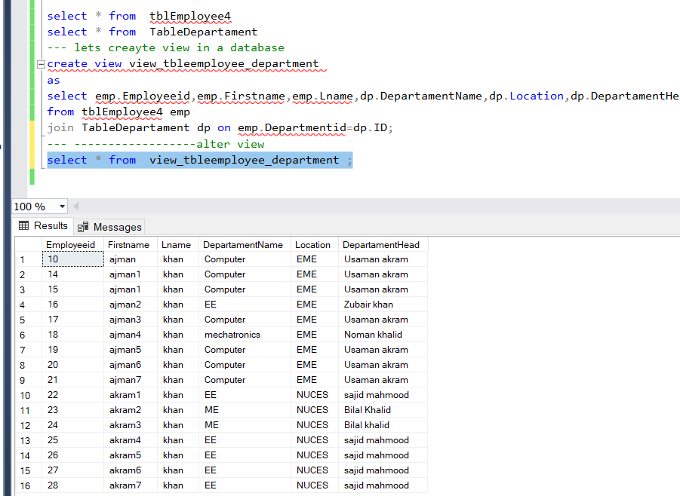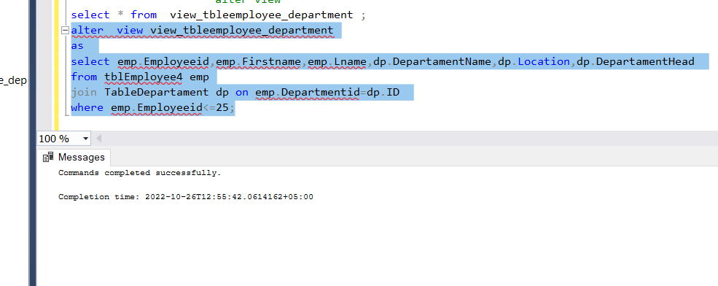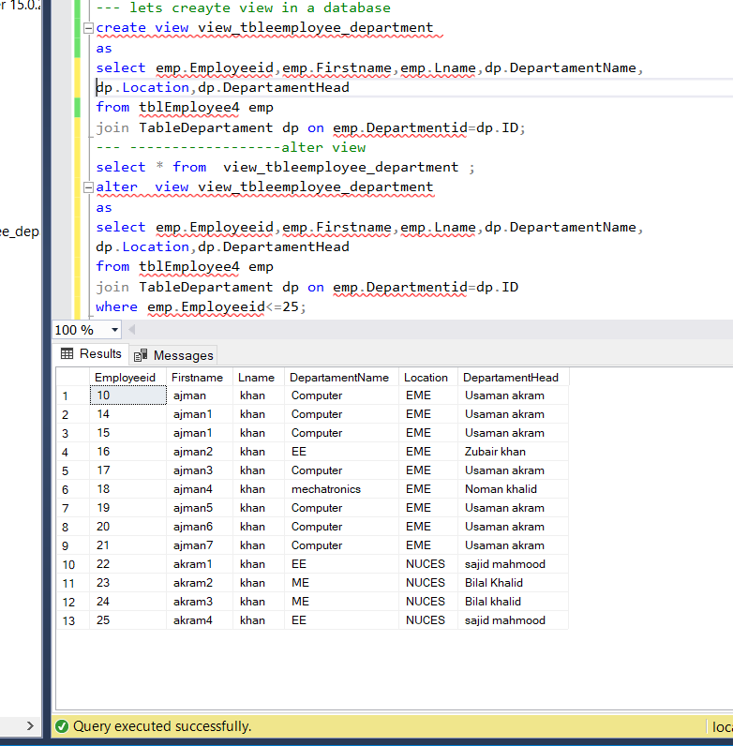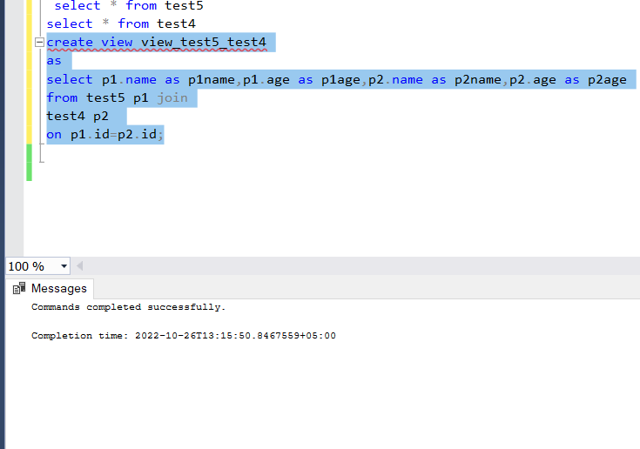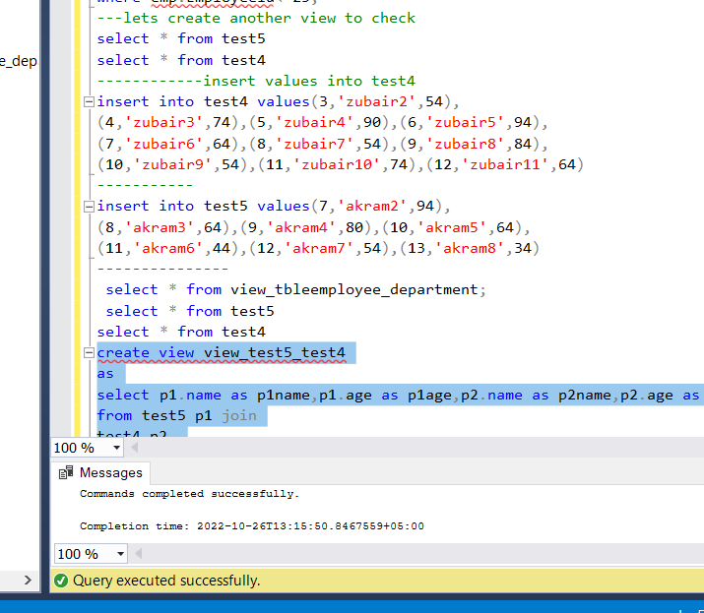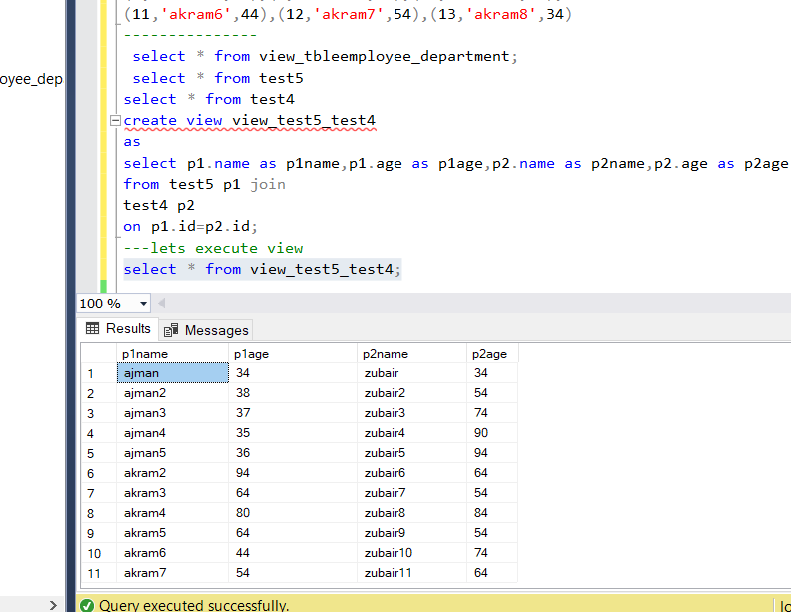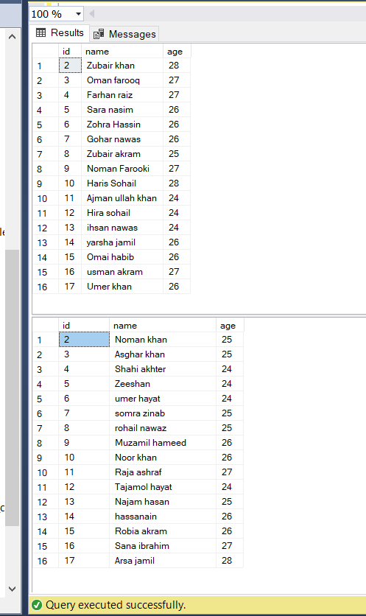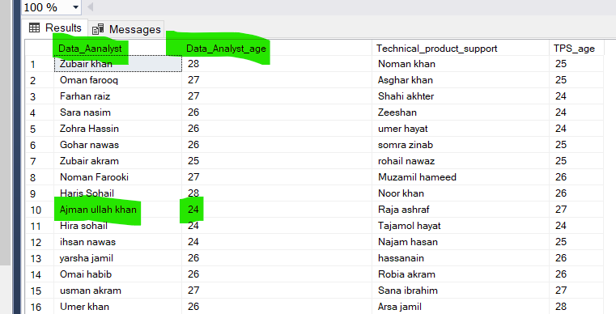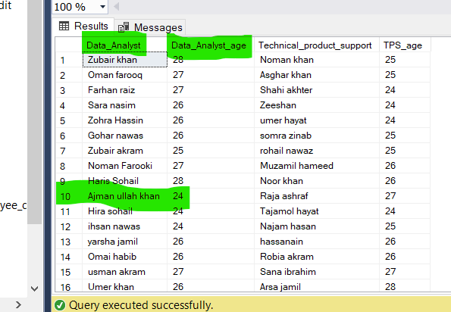

insert into tblEmployee4 values('ajman1','khan',7),

('ajman2','khan',2),('ajman3','khan',3),('ajman4','khan',4),

('ajman5','khan',5),('ajman6','khan',7),('ajman7','khan',5)

----------------------------------------------------

select * from tblEmployee4

select * from TableDepartament

-----------------------------------------------

insert into TableDepartament values('EE','NUCES','sajid mahmood'),

('ME','NUCES','Bilal Khalid'),('ME','NUCES','Bilal khalid'),

('EE','NUCES','sajid mahmood'),('EE','NUCES','sajid mahmood'),

('EE','NUCES','sajid mahmood'),('EE','NUCES','sajid mahmood')

----------------------------

select * from tblEmployee4

select * from TableDepartament

-----------------

insert into tblEmployee4 values('akram1','khan',8),

('akram2','khan',9),('akram3','khan',10),('akram4','khan',11),

('akram5','khan',12),('akram6','khan',13),('akram7','khan',14)

-----------

select * from tblEmployee4

select * from TableDepartament

--- lets creayte view in a database

create view view_tbleemployee_department

as

select emp.Employeeid,emp.Firstname,emp.Lname,dp.DepartamentName,

dp.Location,dp.DepartamentHead

from tblEmployee4 emp

join TableDepartament dp on emp.Departmentid=dp.ID;

--- ------------------alter view

select * from view_tbleemployee_department ;

alter view view_tbleemployee_department

as

select emp.Employeeid,emp.Firstname,emp.Lname,dp.DepartamentName,

dp.Location,dp.DepartamentHead

from tblEmployee4 emp

join TableDepartament dp on emp.Departmentid=dp.ID

where emp.Employeeid<=25;

---lets create another view to check

select * from test5

select * from test4

------------insert values into test4

insert into test4 values(3,'zubair2',54),

(4,'zubair3',74),(5,'zubair4',90),(6,'zubair5',94),

(7,'zubair6',64),(8,'zubair7',54),(9,'zubair8',84),

(10,'zubair9',54),(11,'zubair10',74),(12,'zubair11',64)

-----------

insert into test5 values(7,'akram2',94),

(8,'akram3',64),(9,'akram4',80),(10,'akram5',64),

(11,'akram6',44),(12,'akram7',54),(13,'akram8',34)

---------------

select * from view_tbleemployee_department;

select * from test5

select * from test4

create view view_test5_test4

as

select p1.name as p1name,p1.age as p1age,p2.name as p2name,p2.age as p2age

from test5 p1 join

test4 p2

on p1.id=p2.id;

---lets execute view

select * from view_test5_test4;

select * from test5

select * from test4

----alter

alter view view_test5_test4

as

select p1.name as Data_Aanalyst,p1.age as Data_Analyst_age,

p2.name as Technical_product_support,p2.age as TPS_age

from test5 p1 join

test4 p2

on p1.id=p2.id;

-----------

alter view view_test5_test4

as

select p1.name as Data_Analyst,p1.age as Data_Analyst_age,

p2.name as Technical_product_support,p2.age as TPS_age

from test5 p1 join

test4 p2

on p1.id=p2.id;

--------------

select * from view_test5_test4;

select * from test5

select * from test4

---- drop the view

DROP VIEW view_tbleemployee_department ;

----- also check

IF OBJECT_ID('view_tbleemployee_department', 'V') IS NOT NULL

DROP VIEW view_tbleemployee_department;

